DO IT – Front End developer

Mini project 3 – Our offer – HTML LINKS – PICTURES -VIDEO

SMART d.o.o, New Frontier Group

Version: 1.0

Revision date: July 26, 2016

Table of Contents

Specification of mini project 2

Requirements for this project 3

Tasks 4

Timeline 5

Tools 6

# Specification of mini project

In this mini project you will done same page as shows in miniproject3-1.jpg and miniproject3-2.jpg.

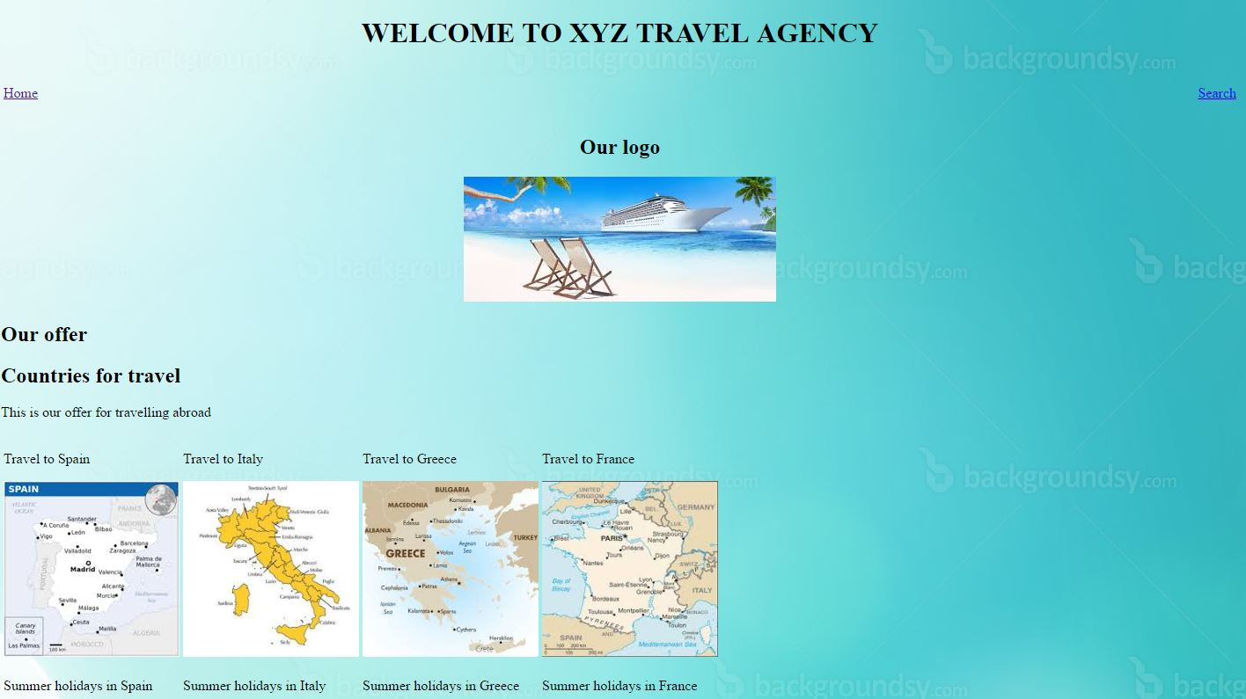

Picture 1 – miniproject3-1.jpg

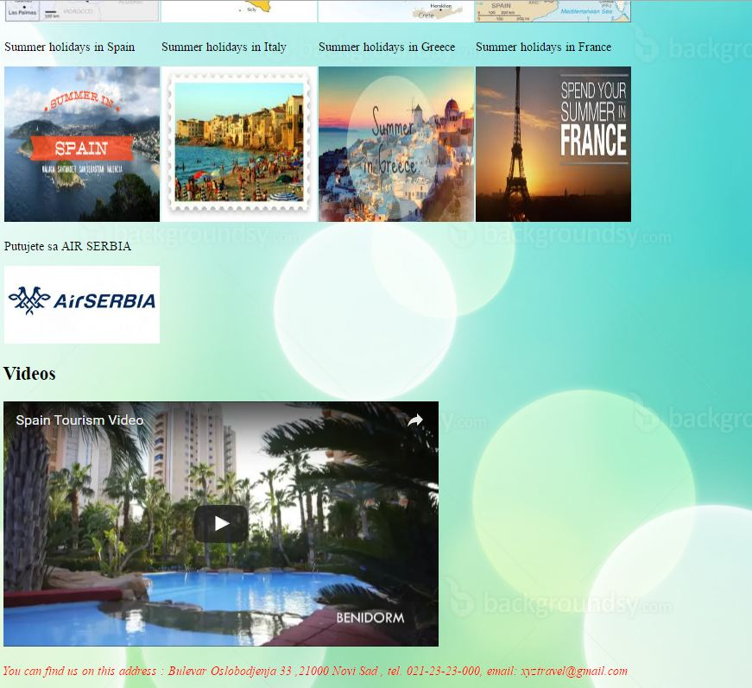

Picture 2 – miniproject3-2.jpg

Your job is to insert pictures in web page and video. Pictures need to be in rows and same width and height. All necessary pictures will be in folder images.

# Requirements for this project

Before you can start with this project you need to finished HTML fundamentals class.

**Tasks**

So your job is to do next :

1. Create new html document and call it pictures.html
2. Insert all necessary tags like in previous projects (head,body,title,meta…)
3. Define title element with text “MINI PROJECT 3” in head tag.
4. Use image background-10.jpg as you background image.
5. Name this site as Welcome to XYZ travel Agency and put this name in h1.
6. Make table with one row and with 100% width.
7. Now make two column in that row and in first set align to left and make link to index.html page and call this link Home.
8. In second column set align to right and make reference to [www.google.com](http://www.google.com) and call this link Search
9. Add text Our Logo in h2 tag. Use pic3.jpg for logo image.
10. Put table and h2 with logo in center of page.
11. Make two h2. In first set Our offer as text and in second put Countries for travel.
12. Make div and then put one paragraph with text This is our offer for travelling abroad. After paragraph put table in this div tag.
13. This table will contain two rows and four columns in each row.
14. Put div in every column. Each column will have text in paragraph and picture. Every picture will be 200 pixels width and 200 pixels height.
15. In first row text and picture that will be used is : Travel to Spain , spain.jpg , Travel to Italy , Italy.jpg , Travel to Greece, Greece.jpg , Travel to France, france.jpg
16. In second row text and picture that will be used : Summer holiday in Spain , summerinspain.jpg, Summer holiday in Italy , summerinitaly.jpg, Summer holiday in Greece , summeringreece.jpg, Summer holiday in France , summerinfrance.jpg
17. Every picture need to have alternate text same as text.
18. Insert paragraph and put next text in it : You can find us on this address : Bulevar Oslobodjenja 33 ,21000 Novi Sad , tel. 021-23-23-000, email: [xyztravel@gmail.com](mailto:xyztravel@gmail.com)

This text need to be italic (use em tag) , and text need to be red and with size.

**Additional tasks**

1. Make new h2 below pictures.
2. Insert new div tag and inside it put table with one row and one column.
3. In column insert iframe tag with width 560 and height of 315 .
4. Also in iframe inser in src tag this link [w](https://www.youtube.com/embed/lTB-izxRuNY)
5. In frameborder tag insert 0 and put tag allowfullcreen without parameters.
6. Refresh page and test if video works.

Your result should look like on picture miniproject3-1.jpg and miniproject3-2.jpg

Good luck!

# Timeline

You will have 3 hours to finish this job.

This timeline is for main parts of the task. Bonus parts should be implemented only if there is extra time left.

# Tools

## IDE and Source Control

You can use either Atom or Brackets tool for development during this project

ATOM - <https://atom.io/>

BRACKETS - <http://brackets.io/>